**Challenge 2 - Esports Tournament**



**Intro**

The top eSports competitors from across the globe have gathered to battle it out

Can you analyse the following data to find out all about the tournament?

**Tables**

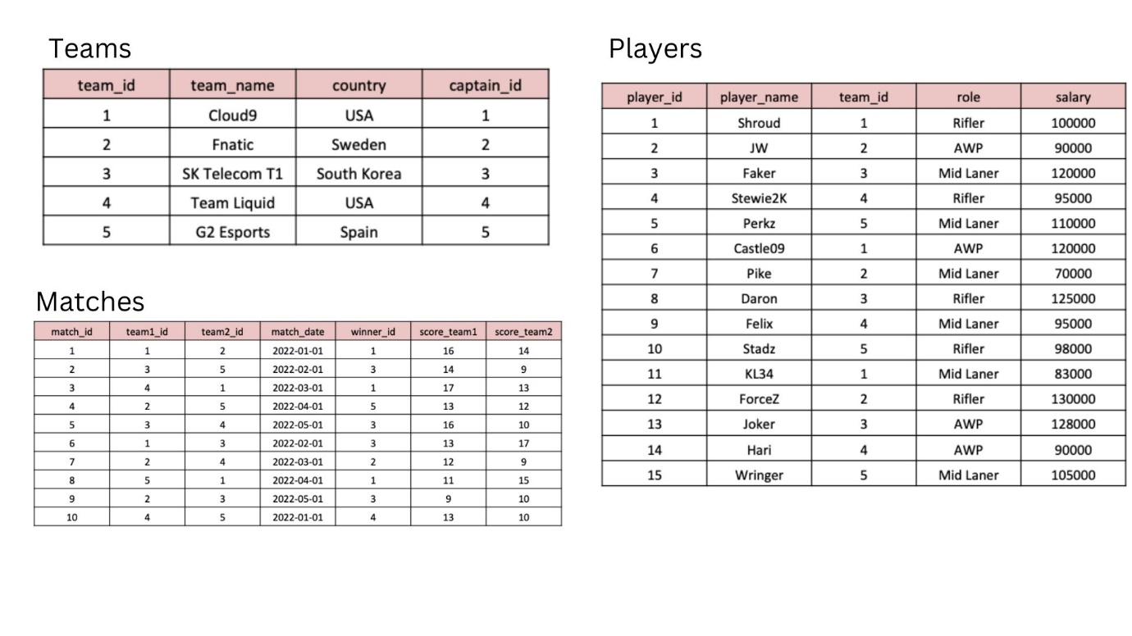

CREATE TABLE Teams (

team_id INT PRIMARY KEY,

team_name VARCHAR(50) NOT NULL,

country VARCHAR(50),

captain_id INT

);

--------------------

INSERT INTO Teams (team_id, team_name, country, captain_id)

VALUES (1, 'Cloud9', 'USA', 1),

(2, 'Fnatic', 'Sweden', 2),

(3, 'SK Telecom T1', 'South Korea', 3),

(4, 'Team Liquid', 'USA', 4),

(5, 'G2 Esports', 'Spain', 5);

--------------------

CREATE TABLE Players (

player_id INT PRIMARY KEY,

player_name VARCHAR(50) NOT NULL,

team_id INT,

role VARCHAR(50),

salary INT,

FOREIGN KEY (team_id) REFERENCES Teams(team_id)

);

--------------------

INSERT INTO Players (player_id, player_name, team_id, role, salary)

VALUES (1, 'Shroud', 1, 'Rifler', 100000),

(2, 'JW', 2, 'AWP', 90000),

(3, 'Faker', 3, 'Mid laner', 120000),

(4, 'Stewie2k', 4, 'Rifler', 95000),

(5, 'Perkz', 5, 'Mid laner', 110000),

(6, 'Castle09', 1, 'AWP', 120000),

(7, 'Pike', 2, 'Mid Laner', 70000),

(8, 'Daron', 3, 'Rifler', 125000),

(9, 'Felix', 4, 'Mid Laner', 95000),

(10, 'Stadz', 5, 'Rifler', 98000),

(11, 'KL34', 1, 'Mid Laner', 83000),

(12, 'ForceZ', 2, 'Rifler', 130000),

(13, 'Joker', 3, 'AWP', 128000),

(14, 'Hari', 4, 'AWP', 90000),

(15, 'Wringer', 5, 'Mid laner', 105000);

--------------------

CREATE TABLE Matches (

match_id INT PRIMARY KEY,

team1_id INT,

team2_id INT,

match_date DATE,

winner_id INT,

score_team1 INT,

score_team2 INT,

FOREIGN KEY (team1_id) REFERENCES Teams(team_id),

FOREIGN KEY (team2_id) REFERENCES Teams(team_id),

FOREIGN KEY (winner_id) REFERENCES Teams(team_id)

);

--------------------

INSERT INTO Matches (match_id, team1_id, team2_id, match_date, winner_id, score_team1, score_team2)

VALUES (1, 1, 2, '2022-01-01', 1, 16, 14),

(2, 3, 5, '2022-02-01', 3, 14, 9),

(3, 4, 1, '2022-03-01', 1, 17, 13),

(4, 2, 5, '2022-04-01', 5, 13, 12),

(5, 3, 4, '2022-05-01', 3, 16, 10),

(6, 1, 3, '2022-02-01', 3, 13, 17),

(7, 2, 4, '2022-03-01', 2, 12, 9),

(8, 5, 1, '2022-04-01', 1, 11, 15),

(9, 2, 3, '2022-05-01', 3, 9, 10),

(10, 4, 5, '2022-01-01', 4, 13, 10);

#1. What are the names of the players whose salary is greater than 100,000?

select player_name

from Players

where salary>100000;

#2. What is the team name of the player with player_id = 3?

select t.team_name

from Teams t join Players p

on t.team_id=p.team_id

where p.player_id=3;

#3. What is the total number of players in each team?

select t.team_id, count(p.player_id) as total_players

from Teams t join Players p

on t.team_id=p.team_id

group by t.team_id;

#4. What is the team name and captain name of the team with team_id = 2?

select t.team_name, p.player_name as captain_of_team

from Teams t join Players p

on t.captain_id=p.player_id

where t.team_id=2;

#5. What are the player names and their roles in the team with team_id = 1?

select player_name, role

from Players

where team_id=1;

#6. What are the team names and the number of matches they have won?

select t.team_name, count(m.winner_id) as matches_won

from Teams t join Matches m

on t.team_id=m.winner_id

group by m.winner_id;

#7. What is the average salary of players in the teams with country 'USA'?

select avg(salary) as avg_salary

from Players p join Teams t

on p.team_id=t.team_id

where t.country='USA';

#8. Which team won the most matches?

select t.team_name, count(m.winner_id) as matches_won

from Teams t join Matches m

on t.team_id=m.winner_id

group by m.winner_id

order by matches_won desc limit 1;

#9. What are the team names and the number of players in each team whose salary is greater than 100,000?

select t.team_name, count(p.player_id) as number_of_players

from Teams t join Players p

on t.team_id=p.team_id

where p.salary>100000

group by t.team_name;

#10. What is the date and the score of the match with match_id = 3?

select match_date, score_team1, score_team2

from Matches

where match_id=3;